Pima-Maricopa Irrigation Project Education Initiative
2005-2006

Restoring water to ensure the
continuity of the Akimel O’otham
and Pee Posh tradition of agriculture

An Agricultural Boon: The Pima and Maricopa Trade Surplus

The organization of the Butterfield Overland Mail Company and the San Antonio and San Diego Mail Line and the selection of the Pima villages as a central stage and mail stop, in 1858, proved to be an economic boon to the Pima and Maricopa. The confederated tribes claimed all of the land and its resources in south-central Arizona, a proposal Isaiah C. Woods, general superintendent of the San Antonio and San Diego Mail Line, soon discovered. Having made several trips across the desert, Woods met in conference with the chiefs and headmen of the two tribes on November 15, 1858.
Part 67

Although Woods did not state the names of the headmen with whom he met, he likely spoke with Head Chief Antonio Azul and the village headmen. Azul and the village captains told Woods that the land, grass, wood and water then utilized by the stage line belonged to them. In addition, Woods was to pay the Indians for the protection provided the travelers and the grass and water the mules and horses consumed at Maricopa Wells. Woods acknowledged Azul’s request and distributed handkerchiefs and cotton cloth as gifts. While not confirming any details of the financial arrangements, Woods complied with them. Having a lengthy history of dealing with emigrants passing through their territory, the Pima and Maricopa headmen served notice: the land and its resources belonged to them and they would exercise sovereignty over both.
Maricopa Wells continued to grow, especially after the Butterfield Company began service in the fall of 1858. By the spring of 1859, a U.S. Post Office opened at the Wells, which not only served as a stop over for emigrant travelers and freighters—providing the last water before the forty-mile desert—but also grew into a trading post that, in time, included a blacksmith shop, hotel and the first military telegraph line in Arizona Territory. By the 1870, it was—along with Prescott—one of two transportation hubs for Arizona Territory, remaining an important communication hub until the Southern Pacific Railroad arrived in 1879 and established Maricopa Junction as the new hub.
The Pima and Maricopa were fully aware of the opportunities provided by the mail lines. John Walker, the first permanent Indian agent assigned to the tribes in 1857, wrote Commissioner of Indian Affairs James W. Denver in January 1858, that he encouraged the Indians “to farm more largely as they can find a good market for a great portion of their grain at home.” The Pima and Maricopa, farming perhaps 10,000 acres at the time, requested farming tools that would enable them to increase production. In the spring of 1858, they informed Walker they needed ploughs, hoes, axes, shovels and spades, all of which were essential to plant more crops in a more efficient manner. Walker promised he would inquire of the Indian Department to see what it might provide.
By May of 1858, the Butterfield Overland Company began construction of a new stage stop five miles above the Pima villages at Capron’s Rancho, which in time became Sacaton Station, or Sacaton. By late summer, then, there were stations above and below the Pima villages, with Maricopa Wells below and Sacaton above the villages. Walker wrote New Mexico Superintendent of Indian Affairs James L. Collins that the Pima had plenty of water and “beautiful acequias” but were somewhat restless that the agricultural tools they had requested were not yet in hand. With a growing market for their crops, Pima-Maricopa farmers were poised to expand operations. Agricultural implements had been purchased, Collins informed Walker, and would be forwarded to the villages as soon as practical.
Delays in fulfilling the government’s good-will gesture led to ill feelings among the Pima and Maricopa, who anxiously awaited the tools. When Lieutenant A. B. Chapman and a detachment of US Army soldiers passed through the villages in late summer, Maricopa village captain Juan Jose grew incensed when they refused his offer of five dollars apiece in gold for shovels and axes. Jose told Chapman, “I believe your people are a nation of liars…. I trust you no more.” Even Antonio Azul was upset, telling Lieutenant Sylvester Mowry that he and his people were “sick of promises made by every white man.”
Walker, meanwhile, found himself in a difficult position, caught between the Pima-Maricopa and government bureaucracy. In November, Walker again dispatched a letter to Collins in Santa Fe, reminding him that the Pima planted two crops a year and that winter crops would be sown between December and February. The Indians “annoy me very much,” the agent told Collins, and were demanding the farm implements. The Pima and Maricopa—wanting to increase commercial trade with the Americans—sought to enlarge their fields and at that very time were constructing a new canal some four miles upstream “where they have never planted before.”
In February 1859, Walker informed Collins it was “important for them (Pima) to have their implements as soon as possible.” The Butterfield Overland Company now had three stage stations—Casa Blanca in addition to Maricopa Wells and Sacaton—in and near the Pima villages and if the Indians were to increase their cultivation, they needed additional tools. This was critical as the Pima had men enough for constructing the new canal upstream but if they were to sow their crop in time they would have to abandon the construction work as they did not have tools to simultaneously do both jobs. The Pima, Walker boasted, were “making considerable effort to increase their planting (and) seem inclined to work and love to make money.”
After months of delay, Walker finally received the ploughs, harrows, spades, axes, blacksmithing and carpenter’s tools promised the Pima and Maricopa and distributed them in March. To further assist Pima farmers with crops, Walker distributed American seed corn, the first non-native corn introduced among the Pima, although they continued to grow their own corn as well. In addition to corn and wheat, the Pima also began growing barley, which Walker also introduced. A passenger on the Butterfield Overland stage noted in June 1860 that the Pima furnished “all the corn and barley required here for the use of the Overland Mail Company.”
The overland stage lines represented more than trade opportunities for the Pima and Maricopa. Because the stage stations also served as communication centers, they also represented the first trading posts and official government centers of social commerce. John Capron, licensed by the Indian Service as a trader in July 1858, was one of the first traders among the Pima. From his post in Sacaton, Capron exchanged trade goods for surplus grain and beans. Since he had an exclusive right to trade with the Pima and Maricopa, Capron had a monopoly, controlling trade in food crops. Such an arrangement did not bode well for the mail companies, with Woods complaining in May 1858 that traders’ exclusive rights would require the San Antonio and San Diego Mail line to buy from speculators rather than directly from the Pima. While the record is silent on Pima and Maricopa concerns, federal licensing requirements enabled traders to acquire monopolies on the reservation that were not in the best interests of the Indians.
The Pima and Maricopa villages had long provided hospitality and food for weary travelers across the Sonora Desert. As emigrant traffic increased—and the overland routes were established—an economic boon was in the making among the Pima and Maricopa. With plenty of water and good fertile land, they again expanded their agricultural endeavors and sold hundreds of thousands of pounds of surplus food to traders, who in turn sold them to mail companies and, eventually, the US Army. By 1859, the villages were booming with agricultural production.

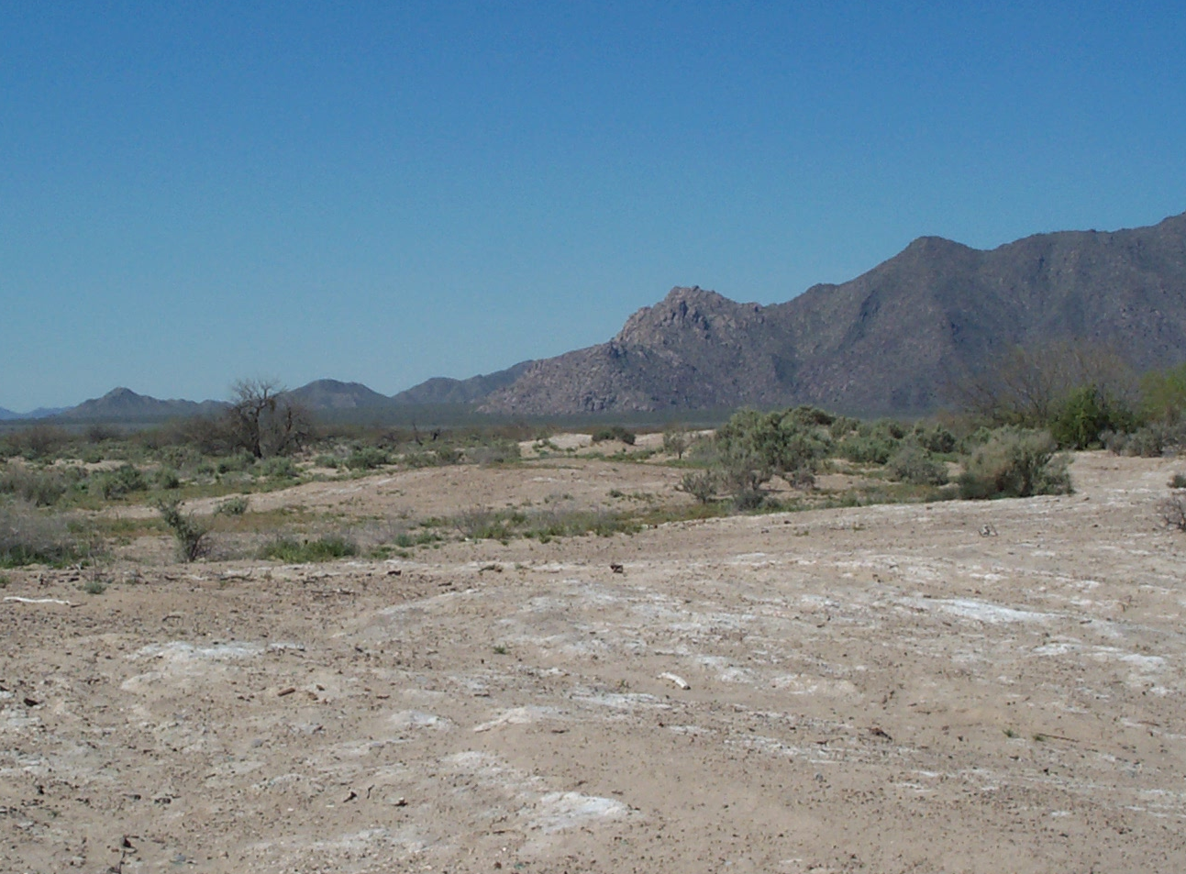

Maricopa Wells today (above) and in 1870 (below). Notice the southeastern tip of the Estrella Mountains in the background of both photographs.

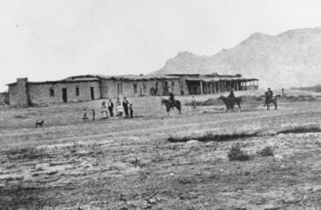
Teacher Plan for “An Agricultural Boon: The Pima and Maricopa Trade Surplus”
Objectives

Students will be able to:

- Describe the economic boon to the Pima and Maricopa that resulted from the overland mail routes.

- Discuss how the Pima and Maricopa responded to new trade opportunities in the 1860s and consider how they can do likewise today now that water settlement is providing another agricultural boon.
Terms to know and understand
- Emigrant
- Sovereignty
- Hub
- Gesture
- Implements
- Monopoly
- Speculator
Critical Thinking:

- The arrival of the stage and mail lines provided an economic boon to the Pima and Maricopa. If one only considers the economic side of the matter, then the trade in surplus crops was indeed a boon. With increased emigrant and military traffic, there were other social and economic impacts—to say nothing of the political implications. What might some of these impacts have been?
Activities:

- When Antonio Azul and the village headmen met with Isaiah Woods in 1858, they discussed with him the fact that the Pima and Maricopa owned the land and its resources. They further expected payment for the use thereof. Was this an exercise of the rights of the Pima and Maricopa to control their land and its resources, an idea known as sovereignty? Discuss other ways in which a nation or people exercises sovereignty. Why is this important? What can you do today to protect the sovereignty of the Gila River Indian Community?
- The Pima and Maricopa were anxious to expand their agricultural activities with the arrival of the overland stage lines. This was true during the “forty-niner” era as well. The Gila River Indian Community water settlement act became law in 2004. Are you anxious to expand agricultural operations today to take advantage of the growing markets in Maricopa and Pinal counties, as well as those national and international? What can you do today to help your Community use this settlement water and expand agricultural operations?
About P-MIP

The Pima-Maricopa Irrigation Project is authorized by the Gila River Indian Community to construct all irrigation systems for the Community. When fully completed, P-MIP will provide irrigation for up to 146,330 acres of farmland. P-MIP is dedicated to three long-range goals:
- Restoring water to the Akimel O’otham and Pee Posh.
- Putting Akimel O’otham and Pee Posh rights to the use of water to beneficial use.
- Demonstrating and exercising sound management to ensure continuity of the Community’s traditional economy of agriculture.

